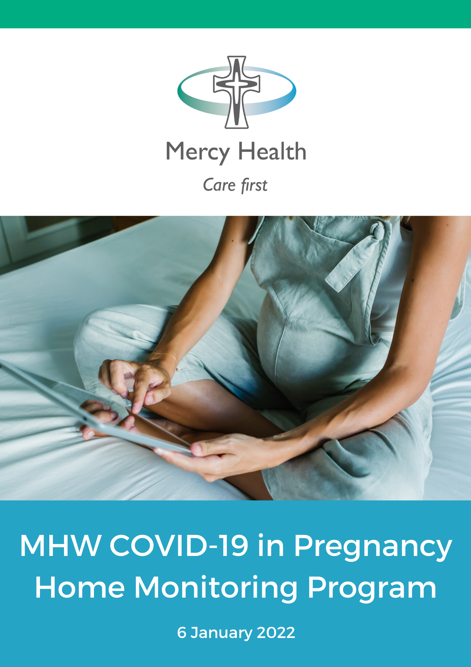

Mercy Health COVID at Home Monitoring Program
You have been enrolled as a patient of Mercy Health COVID at Home Monitoring program. This is a program that is monitoring the health of you and your baby when you have COVID-19 and are isolating at home.

For most women, COVID-19 will be a mild flu-like illness and it won’t cause problems for you or your baby, especially if you have been vaccinated.

This document has 10 sections; you can go directly to the section of interest by clicking on the links below:

1. I have tested positive to COVID 19, what now? 3
2. What happens to pregnant women if they have COVID 19? 3
3. What are the symptoms of COVID 19? 4
4. How should I monitor my symptoms? 5
5. What can I take to manage my symptoms at home? 7
6. Will the Mercy contact me if I have COVID 19? 7
7. Who else is involved in my care while I have COVID-19? 8
8. Will I need additional treatments for COVID 19? 9
9. What happens if I need to give birth while I am still in isolation? 10
10. I feel like I am getting more unwell: what should I do? 10

  - About COVID-19
COVID-19 stands for "Coronavirus Disease 2019." It is caused by a virus called SARS-CoV-2 that can spread from person to person. This usually happens when an infected person coughs, sneezes, or talks near other people.
COVID-19 symptoms generally develop 4 to 5 days after a person is infected. You are thought to be infectious from 2 days before the onset of symptoms. If you don’t have symptoms, you are considered infectious from 2 days prior to your positive swab. Most people who have COVID-19 will be asymptomatic, or will have minor symptoms.

I have tested positive to COVID 19, what now?
- If you test positive for COVID-19 you must immediately go home and isolate. Do not make any stops on the way home.
- During isolation you must stay in your home and away from other people in your household.
- You cannot leave your house for any reason unless it is an emergency, you need medical help, or to escape family violence.
- Do not attend regular outpatient appointments whilst you are in isolation
- The Department of Health may notify you when you can finish your isolation and safely leave your home, but this is generally 7 days after you test positive and symptoms have cleared
- You need to advise your close and social contacts that you are positive (see advice at https://www.coronavirus.vic.gov.au/checklist-cases)
- Answer calls from Mercy Health COVID at Home Monitoring Program team
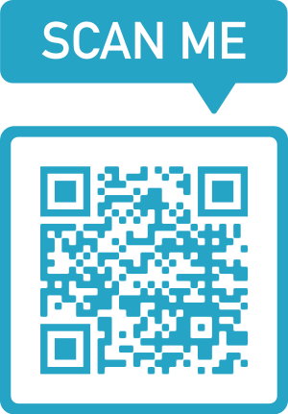
- Seek help if you become more unwell
More information?
Follow the checklist for COVID positive cases via the link below
(or scan the QR code):
https://www.coronavirus.vic.gov.au/checklist-cases

What happens to pregnant women if they have COVID 19?
If you have been vaccinated, you will very likely have a very mild course, or have no symptoms at all. Vaccination protects, you, your baby and your family. COVID vaccines reduce the risk that you will become infected with COVID-19 and drastically reduce the risk of you developing serious illness. It is still recommended that you have (or complete) the vaccination course after you have recovered from COVID-19. Furthermore, COVID- 19 isn’t transmitted to the baby when you are pregnant with COVID 19.
Some pregnant women are at increased risk of severe illness. These are women who are unvaccinated (or incompletely vaccinated), are obese (BMI greater than 30), are greater than 35 years of age, have other medical conditions (such as pre-pregnancy diabetes, heart or lung conditions, immunosuppressed) or are in later pregnancy. Most of these women will also have a mild disease but if they develop more serious illness, they are more likely to be hospitalised and require intensive care. Women who develop severe illness have a higher chance of the baby being born preterm, stillborn or requiring a caesarean birth.
This is why we closely monitor women with risk factors throughout your illness, so we can make sure you are not developing severe disease. We and/ or the Public Health Unit at your local hospital will ring you regularly during your illness to monitor you and your baby’s health. It is important that you monitor your symptoms and seek help if your symptoms worsen.
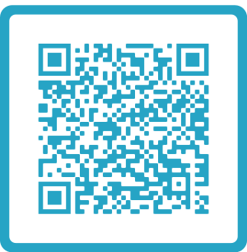
More information?
If you are after more information about COVID 19 in pregnancy,
follow this link (or scan via QR code):
https://www.pregnancybirthbaby.org.au/coronavirus-covid-19-and-pregnancy#information

What are the symptoms of COVID 19?
When symptoms occur, they can include:
- Fever
- Chills or sweats
- Cough
- Feeling tired (lethargy)
- Muscle/ joint pains
- Headache
- Sore or scratchy throat
- Runny nose
- Trouble breathing (Shortness of breath)
- Loss or change in sense of smell or taste
- Loss of appetite
- Vomiting
- Diarrhoea

For most people symptoms generally last a few days and rarely a few weeks. These can mostly be monitored and managed at home (See 4. How should I monitor my symptoms? and 5. What can I take to manage my symptoms at home?).

How should I monitor my symptoms?
You should monitor the above symptoms while at home in isolation. Keeping a diary is helpful so you can monitor change over time.
Most women will have no symptoms or mild symptoms but it is worth specifically paying attention to:
- Your Breathing

- You should note whether your breathing is difficult; for example do you become breathless when you walk, when you are sitting at rest or when you are speaking?
- You can count your respiratory rate. Try to relax and breathe normally. Set a timer for 30 seconds, and start to count the number of times you breathe in and out before the time is up. Double this number and this will be your respiratory rate per minute.
- If you are considered at higher risk, you will be provided with an oximeter (which measures the oxygen level in your blood). If you have an oximeter, you will be provided with instructions on how to use it and record your oxygen levels. You should use this to measure your oxygen levels and heart rate 3 times/ day. Your oxygen level should be greater than or equal to 95%.
If your breathing is becoming more difficult, your respiratory rate is increasing, or your oxygen level is less than 95%, this is a sign that you need to be reviewed by a doctor.
- Heart rate

You can check your heart rate by feeling your pulse, or having it measured with the oximeter. To measure your heart rate, place your fingers lightly on your wrist, and count the number of beats that you feel over 30 seconds. You then need to calculate the beats per minute by doubling the number of beats you counted over 30 seconds. This number is your heart rate.
If your heart rate is greater than or equal to 120 beats per minute, this is a sign you need to be reviewed by a doctor
- Temperature

You can measure your temperature at home with a thermometer. If you don’t have a thermometer, you can buy one from a pharmacy over the phone or online, and have it delivered to your home.

In pregnancy, we like your temperature to be less than 38 degrees.
In summary, if you are monitoring your heart rate, respiratory rate or temperature at home, these are the important parameters:
The Green Zone
- If your respiratory rate is less than or equal to 20 breaths per minute.
- If your heart rate is less than or equal to 100 beats per minute.
- If your temperature is less than or equal to 38 degrees.
Continue to monitor and record your breathing, heart rate and temperature twice per day.
The Orange Zone
- If your respiratory rate is greater than 20 breaths per minute but less than or equal to 24 breaths per minute.
- If your heart rate is greater than 100 beats per minute but less than or equal to 120 beats per minute.
- If your temperature is greater than 38 degrees (despite Panadol), but less than or equal to 38.5 degrees.
Re-check in 2 hours’ time. You should increase your monitoring to 4 times per day until your breathing, heart rate and temperature are back in the green zone.
The Red Zone
- If your respiratory rate is greater than 24 breaths per minutes, if your breathing is becoming more difficult, or your oxygen level is less than 95%.
- If your heart rate is greater than 120 beats per minute.
- If your temperature is greater than 38.5 degrees despite Panadol.
You need to see a doctor.

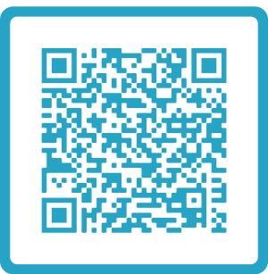
More information?
You can get more information about monitoring symptoms at
home, or do a symptom checker questionnaire here
(or scan via QR code):
https://www.healthdirect.gov.au/managing-covid-19/monitoring-covid-19-symptoms

What can I take to manage my symptoms at home?
Simple home remedies seem to work the best:
- Soothing drinks (honey and lemon), warm tea, lemon in hot water for cough or sore throat
- Cool showers, a fan, cool face washers for fever
- Steamy showers for nasal congestion or saline nasal sprays
- Panadol is safe to take every 6 hours
  - Take this for fever, headaches and or muscle aches
  - Do not take Nurofen or other over-the counter product without checking with your doctor, midwife or home monitoring team,
- Rest as much as possible but do some gentle walking around every 2- 4 hours during the day
- Drink lots of fluids (water, juice, soups, gastrolyte)
- Eat if hungry, including fresh fruit and vegetables
Remember the symptoms will pass. Nasal congestion and loss of smell and taste seem to be the last to go.
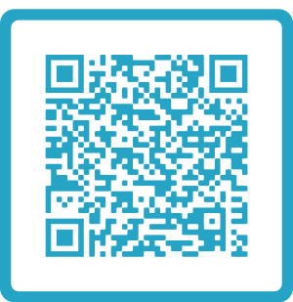
How do I isolate at home?
Isolating from other family members (especially young children)
can be difficult. For more information on isolation, quarantine and
how to isolate at home, click on the link below (or scan via QR code):
https://www.healthdirect.gov.au/coronavirus-covid-19-self-isolation-faqs

Will the Mercy contact me if I have COVID 19?
The Mercy COVID monitoring team will call you when we hear you have a positive COVID result to:
- Work out if you at risk for moderate to severe COVID infection.
  - If you are high risk, such as not having received a complete course of vaccinations or have medical conditions, you may have some medicines prescribed.
- Check on pregnancy health by telehealth. We will work out:
  - what face to face appointments can be put off until you are out of isolation.
  - if you need a face-to-face check-up in a COVID isolation room in MHW Emergency department, called “Orange Clinic”.
- After this triage call, the number of COVID monitoring calls will be individualised to your needs.
LOW RISK WOMEN
  - Most ‘low risk’ women will not need further specific contact during their isolation period, but you should monitor your COVID symptoms and baby’s movements and contact us anytime if you are concerned (contact links below)
  - You may also receive calls from the COVID pathway hospital while in isolation.
HIGHER RISK WOMEN
  - If you are sicker or have risk factors for severe disease, you will receive calls regularly during your isolation period from a midwife, obstetrician, physician or senior, supervised medical students.
  - We work alongside local Public Health Units (PHU) and the Department of Health (DH) and COVID community pathways. (See below for more information).
Calls usually stop when you have recovered. You are likely to have a discharge call in the 2nd week of your illness. If you have had severe COVID, we will follow you through until day 14 or until you are recovered.
AFTER YOU HAVE RECOVERED
After you have recovered from COVID-19 and have finished isolation we will book you back to your regular pregnancy or post birth check-ups. If you have been very sick and admitted to hospital, you might have follow up with a physician and if you still have some weeks remaining in pregnancy, we will arrange a growth ultrasound scan.

Who else is involved in my care while I have COVID-19?
- You will be contacted by your Local Public Health Unit, and the Department of Health (DH).
- Most women with COVID are also linked to a “Pathway” hospital.
1. Local Public Health Unit
You will receive contact from a local public health unit (e.g. North Eastern Public Health Unit; NEPHU) to inform you of your test results, perform contact tracing and inform you of isolation requirements. They can also organise financial supports, and help with food/groceries, accommodation and getting pharmacy medications delivered.
A COVID Monitoring Team from your local Pathway hospital (Austin Hospital, Eastern Hospital, Northern Hospital, St. Vincent’s Hospital) may also contact you regularly. These teams are part of the local public health unit and monitor your medical health alongside the Mercy Health COVID at Home Program (which is to manage any pregnancy problems).
2. Department of Health (DH)
You may receive contact from the DH throughout your isolation to check in with how you are and to ensure you are complying with isolation requirements. You can call the Department’s Coronavirus Hotline to request financial, accommodation or food/grocery support (24 hours, 7 Days: 1800 675 398).
The DH is responsible for clearing you from isolation.
Mercy Health COVID at Home Monitoring program is not able to clear you from isolation.
3. COVID community “pathways”
COVID community pathway hospitals include: Austin Health, Eastern Health, Northern Health and St Vincent’s Health. All these hospitals have Intensive Care Units for the sickest COVID patients. Their pathways link with local pharmacies and hospital-at-home or hospital-without-walls programs. They will be in touch with you for telehealth from doctors and nurses. The pathway hospital might
- loan you a home oxygen and pulse monitor (Oximeter)
- ask you to track your symptoms using an App
- have a virtual Emergency Department (ED) to help you with problems not related to pregnancy

Will I need additional treatments for COVID 19?
Women at increased risk of severe disease may be offered some specific additional treatments for COVID 19, even if they are not unwell enough to need hospitalisation. These include
- Antibody medications (sotrovimab) for women with risk factors who are incompletely vaccinated or immunosuppressed.
- Blood thinning injections (Clexane) for women who have additional risk factors for clots in the leg/ lungs.
- Inhaled steroid puffer (Budesonide) for women with risk factors.
We will provide you with additional information regarding these treatments if they are recommended for you, and you will be able to discuss this with your doctor or senior midwife.

What happens if I need to give birth while I am still in isolation?
Mercy Hospital Women has all the facilities necessary to look after you, your partner and your baby safely in the event you are still in isolation when you come into labour or the baby needs to be born. If you are close to term, we will provide you with additional information about how and when to contact us, and the details of how and where you will be looked after in the hospital.

I feel like I am getting more unwell: what should I do?
Do I need an ambulance?
If you develop any severe symptoms, such as:
- Severe shortness of breath or difficulty breathing
- Your breathing gets worse suddenly (or, if you have an oximeter, oxygen saturations less than or equal to 92%)
- Coughing up blood
- Lips or face turning blue
- Skin cold and clammy, or pale and mottled
- Pain or pressure in your chest
- Fainting or often feeling like you will faint
- Become agitated, confused, or very drowsy
- A rash that does not fade if you roll a clear glass over it
You should call Triple Zero (000) immediately, tell them your symptoms and let them know you have COVID-19.
Do I need to be seen in hospital?
If you do not have any of the above symptoms but have:
- increasing shortness of breath
- oxygen saturation less than 95% (but greater than 92%)
- vomiting and unable to keep fluids down
- severe, constant headache
- fever greater than or equal to 38.5 degrees despite Panadol
- making very little urine (wee)
you should be seen by a doctor. This could be via:
- Virtual Triage at the Northern Hospital
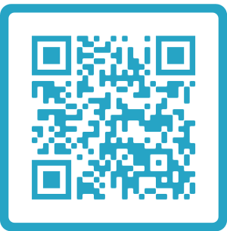
Northern Health Virtual ED (24 hours, 7 Days for COVID positive patients), click on the link below (or scan via QR code):

https://www.nh.org.au/service/emergency-department/

OR
- at your local Emergency Department (Austin, Eastern, Northern Hospital)
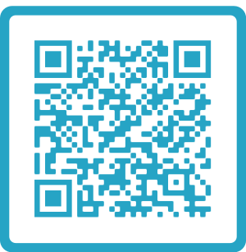
More information about when to seek help with COVID-19
symptoms, click on the link below (or scan via QR code):
https://www.ambulance.vic.gov.au/covid-19-coronavirus-av/

Concerns regarding the pregnancy
If you have concerns about the baby’s movements, think you are in labour, or have bleeding, pain or fluid leak, ring the Hotline 8458 4152 or Emergency Department of Mercy Hospital for Women. Phone: (03) 8458 4000.

Regular appointments during isolation
If you need to have a regular ultrasound, heart rate monitoring of the baby or a blood test during your isolation period, we will organise an appointment time for you.
If you are well and require information or have questions about your pregnancy:
Mercy Health COVID at Home Monitoring Program Team (Monday to Sunday, 8:00am - 4:30pm). Phone: (03) 8458 4152

If you are well and require information or have questions about your isolation or testing requirements:
Department of Health Coronavirus Hotline (24 hours, 7 Days)
Phone: 1800 675 398

