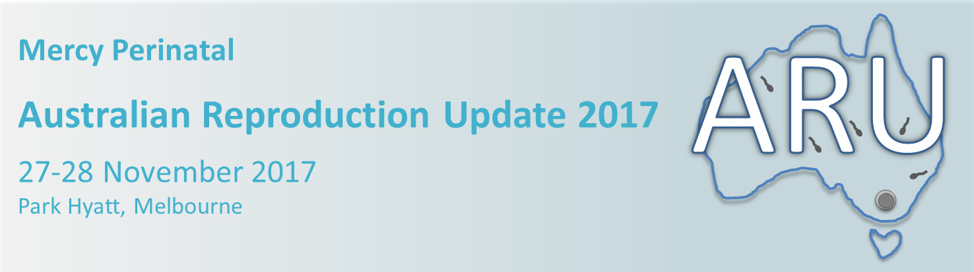

Abstract Submission

Thank you for your interest in submitting an abstract for ARU 2017 (Mon 27- Tues 28 Nov). This conference has a focus on reproduction and pregnancy and we welcome abstract submissions with a focus on gametes, the embryo, implantation, the placenta and pregnancy. Abstracts will be reviewed by a scientific committee for scientific rigor and the top 20 abstracts will be chosen to present in a special free oral communication session at the meeting. To showcase some of the new and emerging talents from around Australia, we are limiting these sessions to PhD students and early postdoctoral candidates. By submitting an abstract, you are acknowledging that you fit within the specified criteria.

Eligibility criteria for abstract submission:
- Honors, masters and PhD students
- Post-doctoral researchers <8 years since PhD obtained

Abstract format
Please submit a structured abstract using the template provided. Maximum total word count of 500, with maximum of 2 graphs/figures.

Submitting an abstract
Please send your completed abstract in an email to: australianreproductionupdate@gmail.com by 30 September 2017

Acceptance and notification
We will email you in September to inform you of the outcome of your abstract.

Australian Reproduction Update 2017
Abstract template

Please note: Abstracts should not be submitted if the content is already published
Title:
Authors and Institution:
Abstract guidelines
Word limit: 500 total
Figure and table limit: 2
Please use the following subtitles in your abstract:
Background, Methods, results, conclusion
The box will ‘expand’ as you enter written information and figures/tables

