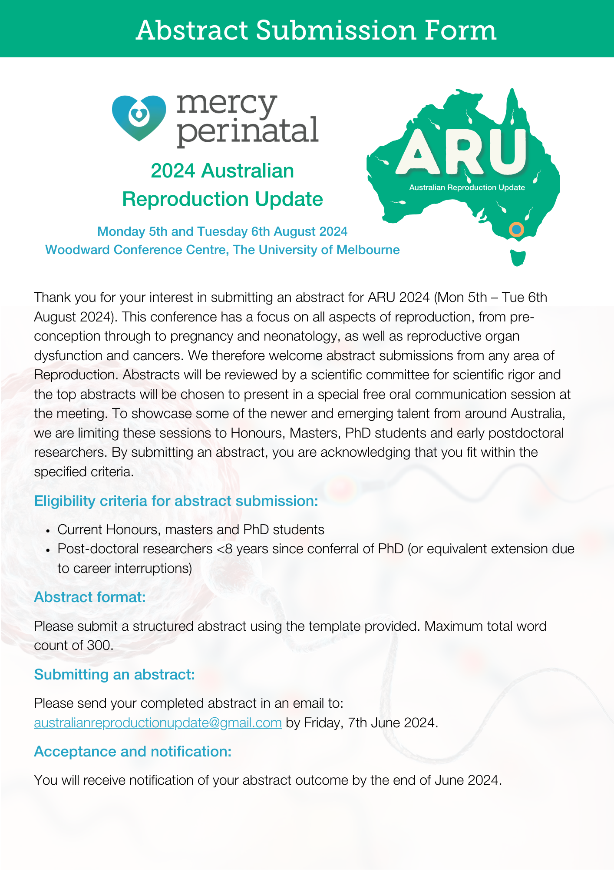
Australian Reproduction Update 2024
Abstract template

Please note: Abstracts should not be submitted if the content is already published

Title:
Authors and Institution:
Abstract guidelines
Word limit: 300 total
Please use the following subtitles in your abstract:
Background, Methods, results, conclusion
The box will ‘expand’ as you enter written information

