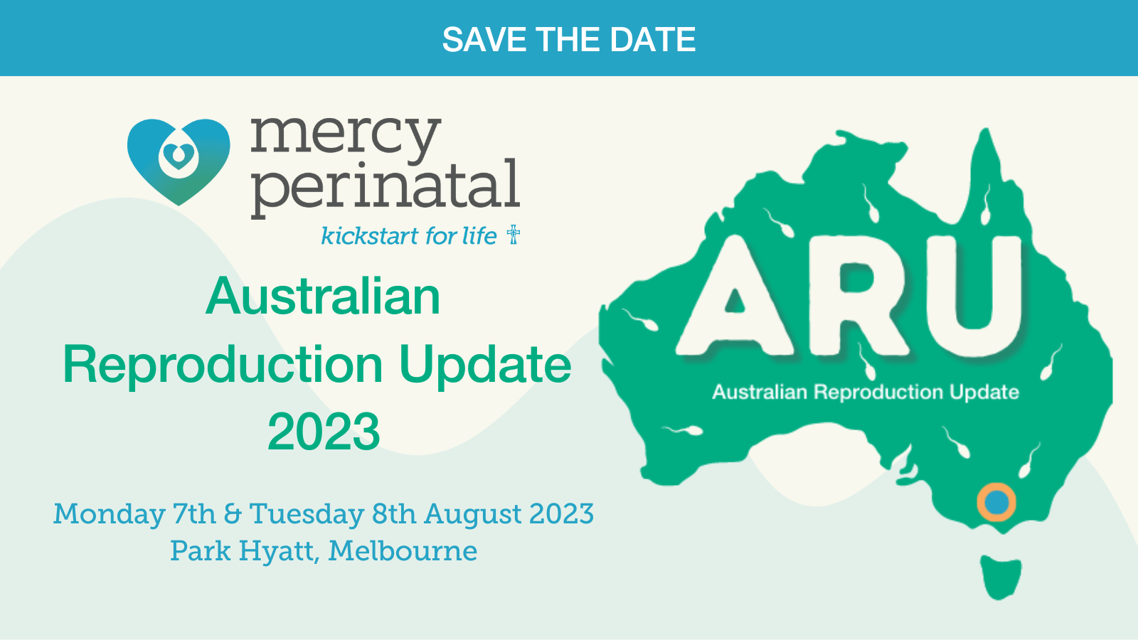

**Abstract Submission**

Thank you for your interest in submitting an abstract for ARU 2023 (Mon 7th – Tue 8th August 2023). This conference has a focus on all aspects of reproduction, from pre-conception through to pregnancy and neonatology, as well as reproductive organ dysfunction and cancers. We therefore welcome abstract submissions from any area of Reproduction. Abstracts will be reviewed by a scientific committee for scientific rigor and the top abstracts will be chosen to present in a special free oral communication session at the meeting. To showcase some of the newer and emerging talent from around Australia, we are limiting these sessions to Honours, Masters, PhD students and early postdoctoral researchers. By submitting an abstract, you are acknowledging that you fit within the specified criteria.

**Eligibility criteria for abstract submission:**

* Current Honours, masters and PhD students
* Post-doctoral researchers <8 years since conferral of PhD *(or equivalent extension due to career interruptions)*

**Abstract format**

Please submit a structured abstract using the template provided. Maximum total word count of 300.

**Submitting an abstract**

Please send your completed abstract in an email to: [australianreproductionupdate@gmail.com](mailto:australianreproductionupdate@gmail.com) by **Friday June 2nd 2023**

**Acceptance and notification**

You will receive notification of your abstract outcome by the end of June 2023.

**Australian Reproduction Update 2023**

**Abstract template**

**Please note:** Abstracts should not be submitted if the content is already published

|  |
| --- |
| **Title:** |
|  |
| **Authors and Institution:** |
|  |
| **Abstract guidelines**  Word limit: 300 total  Please use the following subtitles in your abstract:  Background, Methods, results, conclusion  *The box will ‘expand’ as you enter written information* |
|  |