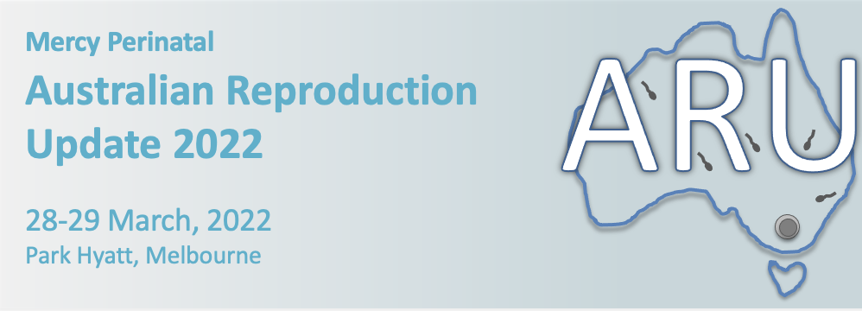

Abstract Submission

Thank you for your interest in submitting an abstract for ARU 2022 (Mon 28-29 March). This conference has a focus on all aspects of reproduction, from pre-conception through to pregnancy and neonatology, as well as reproductive organ dysfunction and cancers. We therefore welcome abstract submissions from any area of Reproduction. Abstracts will be reviewed by a scientific committee for scientific rigor and the top abstracts will be chosen to present in a special free oral communication session at the meeting. To showcase some of the newer and emerging talent from around Australia, we are limiting these sessions to Honours, Masters, PhD students and early postdoctoral researchers. By submitting an abstract, you are acknowledging that you fit within the specified criteria.

Eligibility criteria for abstract submission:
- Current Honours, masters and PhD students
- Post-doctoral researchers <8 years since conferral of PhD (or equivalent extension due to career interruptions)

Abstract format
Please submit a structured abstract using the template provided. Maximum total word count of 300.

Submitting an abstract
Please send your completed abstract in an email to: australianreproductionupdate@gmail.com by Friday Feb 11th 2022

Acceptance and notification
You will receive notification of your abstract outcome by the end of Feb 2022.

Australian Reproduction Update 2022
Abstract template

Please note: Abstracts should not be submitted if the content is already published
Title:
Authors and Institution:
Abstract guidelines
Word limit: 300 total
Please use the following subtitles in your abstract:
Background, Methods, results, conclusion
The box will ‘expand’ as you enter written information

